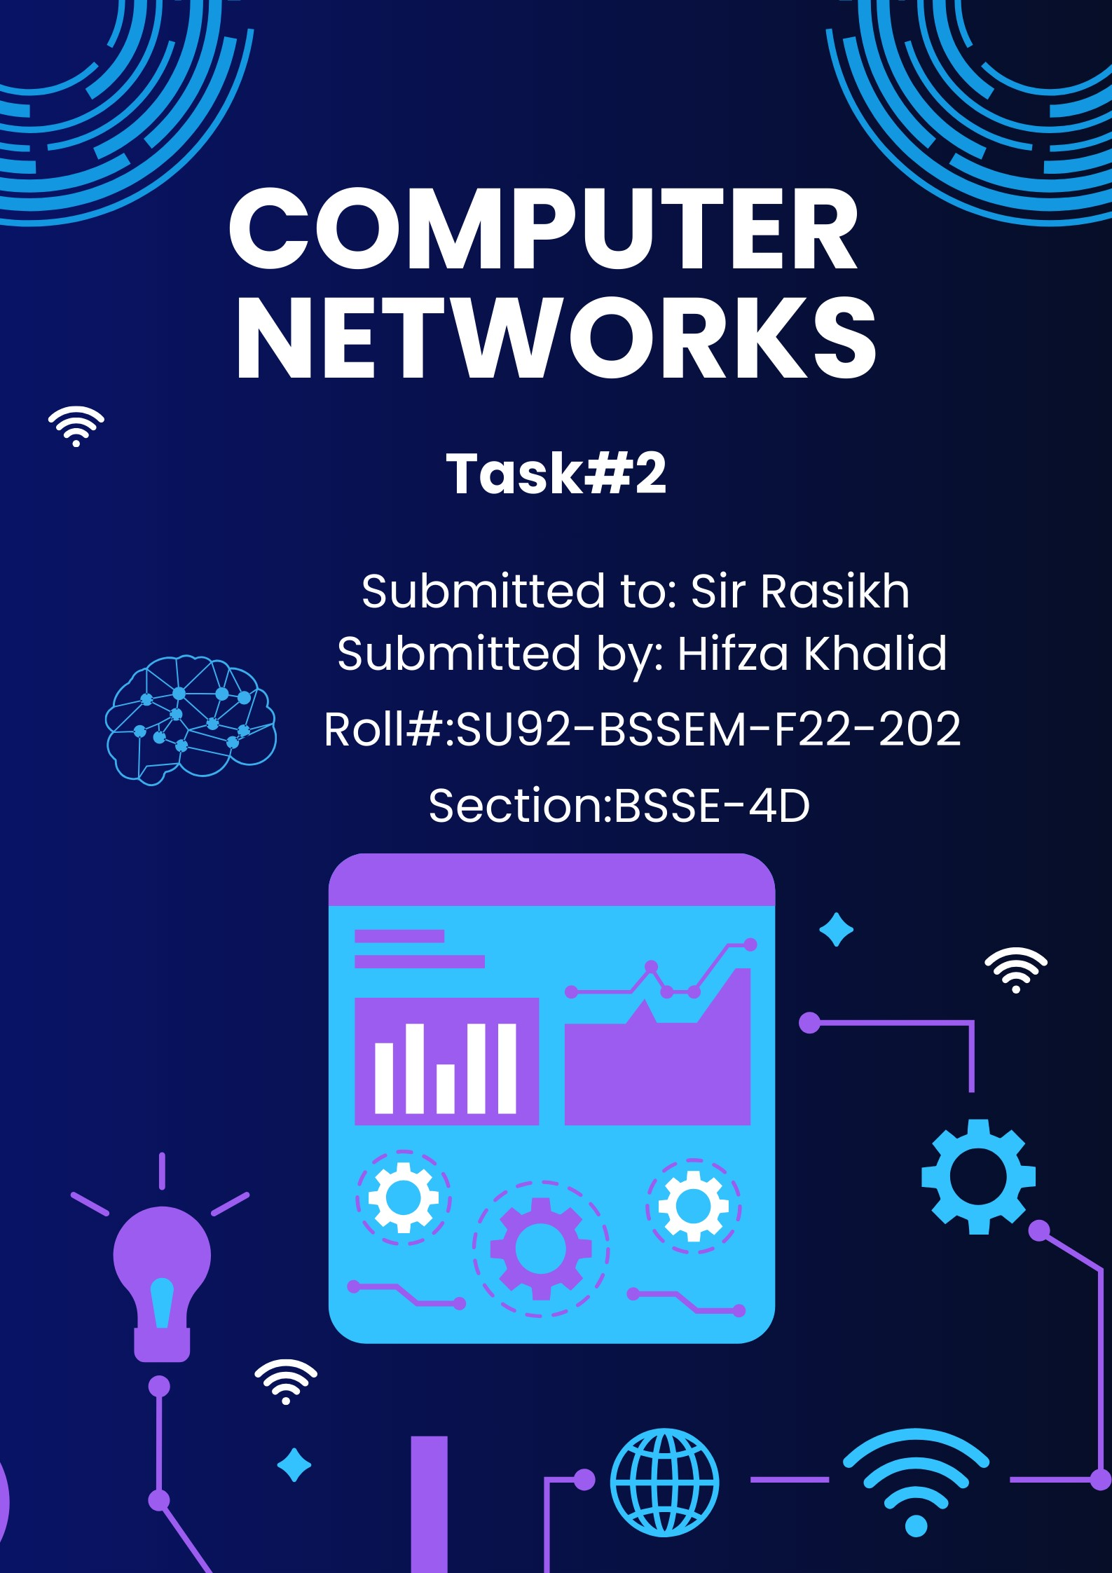

**Establish Connectivity between End Devices**

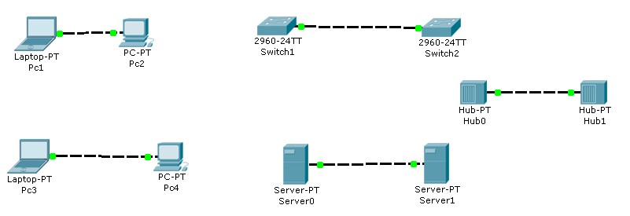

1. Drag & Drop All the END devices & Intermediary devices
2. Connect these Devices with Copper Cross over cable
3. After establishing the connectivity between all the devices check that all devices must be Showing GREEN signal

# Establish Connectivity A Client & Switch

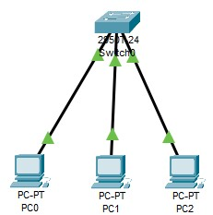

1. Drag & Drop All the END devices & Network device (switch)
2. Connect these Devices with Straight through cable
3. After establishing the connectivity between all the devices check that all devices must be Showing GREEN signal

# Establish Connectivity Between End Devices & Switch & Router

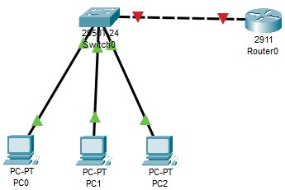

1. Drag & Drop All the END devices & Network device (switch & router)
2. Connect these End Devices with Switch using Straight through cable
3. Connect the Switch with Router using Copper Crossover cable
4. After establishing the connectivity between all the devices check that all devices must be Showing GREEN signal (except router to switch)
5. Click on router and go to config and open the port which is in use (GigabitEthernet0/0 or 0/1 or 0/2)

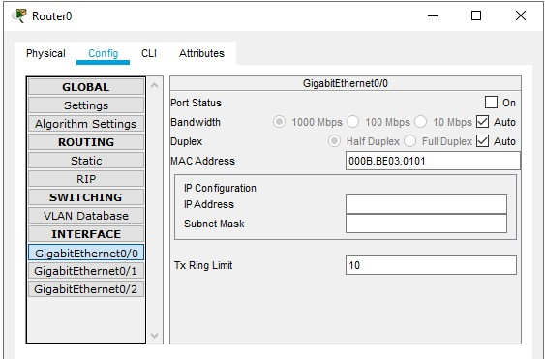

1. Click on the “Port Status” and turn it on.
2. After turning it on the connectivity between all the devices must be Showing GREEN signal

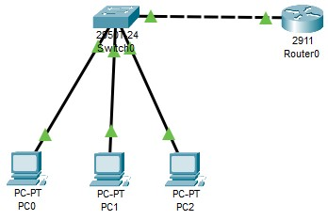

**Task 1:**

**Why are we using 2911 router and not the others?**

The Cisco 2911 router is often chosen over other models for several key reasons:

**1. Scalability and Performance:** The 2911 router provides enhanced performance and scalability, making it suitable for medium-sized networks with a mix of voice, video, and data traffic. It can handle more advanced services compared to some other models like the 1841 or 1941.

**2. Built-in Security Features:** It comes with advanced security features like firewall, VPN, and intrusion prevention, which are essential for enterprise networks. This is especially useful in scenarios where secure communication is crucial.

**3. Modularity:** The **2911** supports a range of interface modules, offering flexibility in terms of connecting different types of networks (e.g., **WAN, LAN, voice**). It’s modular and can be customized depending on the specific needs of the network, making it versatile.

**4. Cost-Effective:** For the features it offers, the 2911 router often strikes a good balance between performance and cost, making it a cost-effective solution for many enterprise environments.

**5. IOS Software:** The 2911 supports Cisco’s IOS software with extensive routing, switching, and network management features. This can be crucial for advanced configurations and maintaining consistency across network devices.

When compared to routers like the **1941** or **2621XM**, the **2911** is more advanced in terms of performance and scalability, especially for networks that need to grow over time.

**Task 2:**

**Why are we using 2950T or 2960 switch and not the others?**

The choice of using Cisco 2950T or 2960 switches over other models typically depends on several factors that make these models ideal for specific network needs. Here are some specific reasons why you might choose the **2950T** or **2960** switch over other models:

**1. Layer 2 Switching**

Both the **2950T** and **2960** are Layer 2 switches, meaning they operate at the data link layer and are designed primarily for local area networks (**LANs**). They handle basic switching tasks such as MAC address learning, forwarding, and filtering. If your network doesn’t require Layer 3 routing capabilities (which are needed for inter-VLAN routing or more complex traffic management), these switches are perfectly adequate.

**2. Cost-Effective Solution**

**2950T:** It's an older model, but it is very affordable, making it a cost-effective option for small to medium-sized networks that need basic Layer 2 functionality.

**2960:** While slightly newer and more advanced than the **2950T**, the **2960** still remains relatively budget-friendly while offering enhanced performance and features.

If you're working with a budget and don’t need advanced Layer 3 features, these switches provide a solid balance between price and performance.

**3. Gigabit Ethernet Support (2960)**

**2960** switches support gigabit Ethernet, which offers faster data transfer speeds compared to older switches like the **2950T**, which is limited to Fast Ethernet.

* This makes the 2960 a good choice for networks that need higher bandwidth, such as environments with more PCs (like your case with **49 PCs**) or devices demanding more data, like IP cameras or VoIP phones.

**4. Reliability and Proven Technology**

Both models are well-known for being reliable and stable. The **2950T** has been widely deployed for years and is known for its simplicity and durability. The **2960** is a more modern option but retains the reliability Cisco switches are known for.

**5. Basic Layer 2 Features (VLANs, Trunking)**

Both switches support essential Layer 2 features, such as:

**VLAN support:** This is critical for segmenting your network into different logical domains.

**Trunking:** For connecting multiple switches or routers together to form a larger network.

**6. Power over Ethernet (PoE) Support (2960)**

The **2960** series (certain models) supports PoE, which allows you to power devices like IP phones, wireless access points, and security cameras directly through the network cable. This feature is a significant advantage if you're running a network with such devices, as it reduces the need for additional power sources.

**7. Switching Capacity**

* The **2960** switch offers better performance and switching capacity compared to the 2950T, allowing it to handle more traffic and provide better throughput in larger or more demanding network environments.

**8. Security Features (2960)**

The **2960** switch comes with advanced security features like port security, DHCP snooping, and access control lists (ACLs), which can help prevent unauthorized access and improve network security.

**9. Network Size and Design**

- If your network requires handling a medium-sized user base with basic functionality, the **2950T** can suffice.

* However, for larger networks or networks that require greater scalability, bandwidth, and modern features, the **2960** is often preferred.

**Conclusion**

* **Cisco 2950T** is a reliable, cost-effective choice for basic, smaller networks.
* **Cisco 2960** is a more modern, versatile switch with faster speeds (Gigabit), PoE capabilities, better security, and overall, more functionality for handling larger or more demanding network environments.

If our network demands features like Gigabit Ethernet, PoE, and improved security, the **2960** is a better choice, while the **2950T** remains a strong option for simpler, smaller networks.

**Task 3:**

**Design the network of "Lab-7" or “Lab-8” (2-3 rows of computers) Use: Switch, Router, & End-Devices like Laptop/PC**

